

**BSc of Innovation & Entrepreneurship Management**

**Group Project**

**“From Ideation to Design”**

***Course Title: Product Design and Development***

***Course Code:***

***Course Instructor:***

***Semester:***

***Group Members:***

***Date of Submission:***

**Table of Content**

**1. Introduction 3**

● Product Name 3

● Target Market and Industry 3

**2. Opportunity Identification 4**

➔ Market Desirability 4

➔ Business Viability 5

➔ Technical Feasibility 5

**3. Category of Customer Needs 6**

**4. Mission Statement 6**

**5. Product Concept Evaluation 8**

● Primary Customer Needs 8

● Measurable Product Specification 9

● Potential Competitors 10

● Benchmark Based on Metrics 11

● Generated Ideas/Solutions 13

**6. Screening Matrix 13**

**7. Scoring Matrix 14**

**8. Sketch 15**

**9. Questionnaire 15**

Responses 17

**CONCLUSION 19**

**10. References 19**

**11. APPENDIXES 21**

# **Introduction**

In a period marked by increasing awareness of the environment and technology breakthroughs, the convergence of environmental responsibility and technological advancement provides an ideal environment for creative businesses. The design of "HydrateTech" exemplifies this combination by providing an innovative approach in the shape of a reusable water bottle coupled with a reminding application. The initiative not solely tackles the sustainability need of decreasing one-time plastic usage, but it additionally leverages technology to encourage customers to adopt appropriate drinking habits. (Mckenzie & Jamnadaas, 2020)

## **Product Name**

"HydrateTech" marks an unprecedented breakthrough within the hydration space, combining the environmentally friendly qualities of a water bottle that can be recycled with the ease of an iOS or Android reminder application. The bottle design is precisely crafted from environmentally friendly components, providing a long-lasting and visually appealing container for everyday drinking. Nevertheless, what distinguishes "HydrateTech" is its connection with an accompanying smartphone application that uses personalized recommendations to encourage people to consume water at specified times during the day. This combination of tactile as well as digital aspects not merely improves sustainability, but it additionally promotes thoughtful consumption behaviors, which improve overall well-being and wellness.

## **Target Market and Industry**

The intended audience for "HydrateTech" includes a wide range of users, from environmentally conscious consumers looking to reduce their ecological footprint to health-conscious people looking to improve their water consumption regimens. Considering a growing focus on health and long-term viability the product appeals especially to urban adolescents and entrepreneurs maintaining lives of excess. Moreover, "HydrateTech" holds an essential position in the rising demand for ecologically conscious consumer products, responding to the growing need for environmentally friendly choices in daily items.

# **Opportunity Identification**

In the case of producing an environmentally friendly water bottle with an alert app, the prospect discovery approach starts with a methodical search of multiple sources to identify unmet requirements or new developments in the market being investigated. This approach often includes market studies, assessment of trends, and customer feedback gleaned from focus groups and polls. On top of that, discussions about ideas and conceptualization conferences could also be held to produce creative concepts for products.Numerous significant factors contributed to people recognising the possibilities for reusing water bottles with a reminding app:

**Market Dynamics:** A detailed assessment of the present state of the market shows that customers are more focused on ecological and wellbeing. Given increasing knowledge of environmental concerns and the negative impacts of plastics that are only used once, there has been a growing desire for sustainable choices in daily items.

**Consumer Statistics:** Feedback from customers and behavior evaluation reveal the demand for products that promote healthy hydration practices. Numerous individuals have busy lives with demanding timetables, which makes it easier to forget the necessity of consuming enough water across the day.

**Technical Developments:** The widespread availability of cellphones and connected watches has resulted in an entirely novel phase of digital wellness and health services. With current advances in technology, it is possible to effortlessly link an alert app with a water bottle that is reusable, giving users an easy solution for tracking and managing their liquid intake.

**Gap Inspection:** A comparison of current marketplace objects finds a lack of alternatives that successfully integrate ecological and digital capabilities. While refillable water bottles are feasible, the addition of an alarm app creates a distinctive selling point that meets both ethical concerns and client wellness demands.

## **Market Desirability**

The market appeal of the reusable water container with a reminder app arises from its compatibility with current customer habits and inclinations. Market studies and consumer data show that there is a rising need for environmentally friendly alternatives in daily items, which is being prompted by increasing worries about the environment. Furthermore, the addition of an application for reminders addresses a prevalent demand amongst people for keeping appropriate hydration behaviors, especially in the setting of a hectic schedule. This twofold selling point broadens the item's allure to a diverse consumer base, including both environmentally ethical customers and health-conscious individuals. (Somani, 2020)

## **Business Viability**

Based on a business standpoint, the product shows potential owing to its possibility of distinctiveness and competitive edge. The refillable water bottle with an app for reminders stands out in the marketplace by integrating environmental and digital capabilities, providing customers with a distinctive benefit. In addition, the scheduling app's a subscription service approach might produce recurrent streams of cash, whilst collaborations alongside eco-friendly businesses or institutional health programmes may widen avenues of distribution and increase revenue.

## **Technical Feasibility**

In terms of technological practicality, advances in developing mobile apps and sensor technologies make it totally possible to integrate a reminding app with a water bottle that can be refilled. The technological elements necessary to run the reminder app, such as alerts and hydration monitoring tools, have been developed and easy to deploy. Furthermore, with biodegradable plastic and other green alternatives available, there are no impassable challenges in producing environmentally friendly components for the plastic bottle itself. In general, the product proposal is well-positioned for profitable commercialization and creation due to its marketplace appeal, company sustainability, and technological competence.

# **Category of Customer Needs**

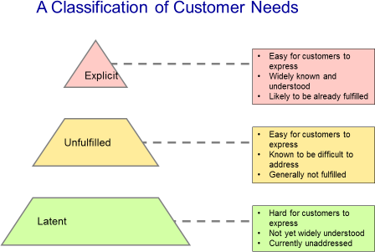

The suggested product, a refillable water bottle with a reminding application, falls mostly within the area of "Unfulfilled Needs" amongst consumer needs categorization. Unfulfilled demands are greetings or demands consumers have which cannot be adequately supplied by current products or alternatives on the marketplace. In this scenario, the pairing of a water bottle that can be recycled and an advisory app fills an industry gap by providing a comprehensive solution that combines environmentalism with digital function to encourage improved hydration practices. By recognising and fulfilling this unfulfilled requirement, the item has the capacity to appeal significantly to customers looking for a quick and environmentally responsible solution to keep hydrated during the entire day.

# **Mission Statement**

| **Mission Statement:** "Our mission is to transform hydrating behaviors by effortlessly combining environmentalism and innovation." We aim to minimize disposable plastic usage whilst encouraging attentive hydration by introducing a water bottle that is recyclable with a reminder app. We are devoted towards delivering an easy remedy that supports individual health and preservation of the environment, which has a good influence on individuals and our planet. | |
| --- | --- |
| **Product Description** | Our product is a reusable water container with built-in reminder software. It's made of recyclable components and has a sleek appearance with a leak-proof cover. The accompanying app provides personalized recommendations to keep users refreshed throughout the day. With this revolutionary solution, we combine simplicity, long-term viability and increased wellbeing into a single bundle. |
| **Benefit Proposition** | Our revolutionary invention blends the convenience of a water bottle that can be reused with the features of an application that reminds you to ensure adequate water intake through the day. By effortlessly combining sustainability with technological simplicity, we allow consumers to put their well-being while minimizing disposable plastic usage, creating an enhanced environmentally responsible lifestyle. |
| **Key Business Goals** | Our primary corporate goals involve promoting environmentally friendly behavior and lowering single-use plastic use through widespread utilization of our water bottle that is reusable with an alert app. We strive to improve user wellbeing by promoting regular water habits while positioning ourselves as a market leader in sustainable technologies. |
| **Primary Market** | Our target market comprises ecologically concerned individuals looking for accessible ways to lessen their impact on the environment while prioritizing their own health. This group consists of people of all ages, mainly urban residents and workers with hectic lifestyles, who respect ecology and are willing to accept new goods that line up with their ideals. |
| **Assumptions and Constraints** | To ensure maximum app engagement, we anticipate extensive use of smartphones within our target group. Furthermore, we believe that consumers are prepared to make investments in environmentally friendly goods, despite potentially greater initial prices.Our key constraints include difficulties in procuring eco-friendly materials, as well as probable technological barriers in developing apps for a variety of different operating platforms. |
| **Stakeholders** | Our interest groups include customers looking for responsible hydration remedies, financiers seeking eco-friendly companies, sustainable material suppliers, developers of applications, and distributors. Furthermore, environmental groups and regulatory authorities are participants interested in encouraging sustainability while minimizing one-time plastic usage. |

**Table 1**

# **Product Concept Evaluation**

To gather information about client demands for our service, a reusable water bottle with a reminder app, we did primary as well as secondary research. The primary study includes carrying out surveys as well as conversations with prospective customers to learn about their hydration routines, tastes, and problems with pain. Additional study entailed examining market patterns, competitive products, and environmentally conscious standards.

## **Primary Customer Needs**

* **Convenience:** Consumers want an easy way to keep hydrated during the course of the day, especially those having hectic schedules who might overlook consuming water on a regular schedule.
* **Long-term viability:** Sustainability issues have led to an increase of consumer demand for sustainable alternatives to plastic bottles that are only used once. Consumers want solutions that help to decrease the carbon footprint and promote ecology.
* **Healthcare and Wellbeing:** Customers prioritize enhanced well-being and health. Many people understand the significance of being maintained for general well-being and seek out solutions that help people maintain sufficient water levels.
* **Incorporation of Technology:** Consumers favor the incorporation of technology in items because it improves usefulness and ease. Our product's alert app addresses this demand by implementing technology to offer personalized hydration recommendations. (Swastika, 2021)

To answer such client expectations, we created an innovative design that emphasizes ecological responsibility while also addressing customer demands for ease and technological connectivity. Our design includes a recyclable water container constructed from environmentally secure components, as well as intuitive notification software that encourages regular water intake. We used creative prototyping technologies to build visualizations and preliminary designs, to guarantee our good fulfills ecological and environmentally friendly standards while exceeding client requirements.

Furthermore, we created an original innovation strategy outlining the procedures for developing, developing, evaluating, and marketing our product. We assessed the monetary viability of our strategy by evaluating manufacturing costs, pricing methods, and predicted revenue sources, as well as guaranteeing that the service we provide fits both consumer demands and corporate goals.

## **Measurable Product Specification**

|  | **Convenience** | **Sustainability** | **Healthcare & Wellbeing** | **Incorporation of Technology** |
| --- | --- | --- | --- | --- |
| **Metric** | Bottled Size | Material Composition | Hydration Tracking | Reminder Frequency |
| **Values** | Small (250 ml)  Medium (500 ml)  Large (750ml) | Recycled plastics, stainless steel, materials that degrade | Automatic monitoring with the manual input alternative | Every 2 Hours |
| **Units** | Millimeters | N/A | N/A | Hours |
| **Metric** | Portability | Carbon Footprint | Water Quality Management | Application Compatibility |
| **Values** | Lightweight | Low carbon footprint and sustainable industrial method | free of BPA, purified alternative. | iOS, Android |
| **Units** | N/A | equivalent to carbon dioxide (kg) | N/A | N/A |

**Table 2**

## **Potential Competitors**

| # | **Product/ Service** | **Customer needs** | **HydrateTech** | **RemindH2O** | **EcoHydrate** | **AquaReminder** |
| --- | --- | --- | --- | --- | --- | --- |
| 1 | Reusable Water Bottle | Convenience:Consumers want an easy way to keep healthy during the day, particularly people with hectic schedules who might overlook consuming water upon a frequent basis. | Bottle dimensions: Medium-sized (500-750ml). Mobility: being lightweight. Product Structure: stainless-steel | Bottle Dimensions: Small (250-500ml); Mobility: Compact. Product structure: reused plastic. | Bottles Measurement: Large (750ml+); Mobility: Robust. Product Structure: Tritan Polymer. | Bottle measurement: Medium (500-750ml). Mobility: waterproof. Material Structure: stainless-steel |
| 2 | Reminder App | Consumers favor the incorporation of technology in items because it improves usefulness & ease. Our product's alert app addresses this requirement by utilizing technology to offer personalized water reminders. | Notification duration: Hourly App integration: iOS & Android. | Notification speed: every 2 hrs; app interoperability: iOS. | Reminder regularly: once every three hours; app integration: Android. | Remind speed: hourly; app integration: iOS |
| 3 | Eco-friendly Materials | Sustainable development: Concerns about the environment have led to an increase of consumer demand for sustainable alternatives to plastic bottles that are only used once. Consumers want solutions that help to decrease the environmental impact and promote environmentalism. | Materials: Reclaimed plastics, Co Footprints: Low emissions of carbon. | Material Structure: Degradable Resources, Carbon Impact: Eco-Friendly Production Method | Material Structure: Reclaimed Plastic; Environmental Impact: Low emissions of carbon dioxide | Material Structure: stainless-steel, Carbon Impact: Responsible manufacturing methods |

**Table 3**

According to the above comparisons evaluation, the product we sell closely matches client requirements by providing an average-sized water bottle that is reusable constructed from aluminum, a reminder application with per hour alerts and integration with iOS as well as Android platforms, as well as environmentally friendly components made of recycled materials with a minimal impact on the environment. But Competitor 1 gives a smaller-sized container constructed from recycled material with alerts every 2 hours, while Competitor 3 delivers an average-sized container constructed of steel that is stainless with hourly alerts but no smartphone connectivity. Competitor 2 provides a bigger bottle constructed from Tritan plastic with a 3-hour reminder and emphasizes sustainability with recyclable components. This benchmarking research helps to uncover advantages and chances for development in what we sell in comparison to rivals, eventually leading towards strategic decisions which enhances competition in the marketplace. (Sharma, 2023)

## **Benchmark Based on Metrics**

| # | **Customer Needs #** | **Metrics** | **Unit** | **HydrateTech** | **RemindH20** | **EcoHydrate** | **AquaReminder** |
| --- | --- | --- | --- | --- | --- | --- | --- |
| 1 | Convenience | Bottle-Sized | ml | Medium 500ml | Small-Sized 250ml | Large-sized 750ml | Medium 500ml |
|  | Portability | Nil | Lightweight | Compactful | Durability | Water-proof |
|  | Composition of Material | Nil | Stainless-Steel | Recyclable Plastics | Tritan Plastics | Stainless-Steel |
| 2 | Sustainability | Composition of Material | Nil | Recyclable Plastics | Materials that decompose | Reclaimed Polypropylene | Stainless-steel |
|  | Carbon- Footprint | CO2 | Minimal pollutants. | Sustainable technique. | Minimal emissions of CO2 | Green methods. |
| 3 | Healthcare & Wellbeing | Notification Interval | Hr | Hourly | Every 2 Hrs | Every 3 Hrs | Hourly |
|  | Compatible Apps | Nil | iOS+Android | iOS | Android | iOS |
| 4 | Technology Incorporation | Notification Interval | Hr | Hourly | 2 Hrs | 3 Hrs | Hourly |
|  | Compatible Apps | Nil | iOS+Android | iOS | Android | iOS |

**Table 4**

According to the benchmarking research, our recently launched item, RemindH2O, is favorably placed in the marketplace relative to other competing firms. We provide a medium-sized water bottle that is reusable constructed from stainless steel in order to fulfill the everyday demands of customers, as well as an app for notifications that provides hourly notifications and is interoperable on Android as well as iOS. Our product additionally emphasizes environmentalism by utilizing reclaimed plastic components and keeping a minimal carbon impact. Although rivals vary in container size, substance, reminder frequency, and app reliability, RemindH2O distinguishes itself by providing an appropriate balance of simplicity, long-term viability and integration of technologies. Ultimately, what we sell has the capability to address consumers' different demands whilst preserving a competitive advantage in the market as a whole.

## **Generated Ideas/Solutions**

To improve our suggested fresh product idea called RemindH2O, we could look into integrating additional functions and specs according to innovative ideas gathered through different channels:

Enhanced Hydrate Monitoring: Include sensors in the container to monitor water consumption and deliver immediate feedback via the app. This functionality would enable consumers to more precisely gauge their water levels and modify how much they drink accordingly.

Customisable Notifications: Allow customers to choose reminder time and frequency depending on their own tastes and schedule. This personalisation option would increase customer engagement and adaptation to diverse cultures.

Smart Degree Controlling: Use technologies to manage the level of the water contained in the container, guaranteeing it stays at the right level for longer. This functionality will be highly appealing to people who enjoy drinking water either hot or cold throughout the day.

Dynamic Tasks and Incentives: Enhance the drinking experiences by introducing tasks and incentives within the application, thus motivating customers to keep refreshed and meet their water intake targets. Discounts on subsequent purchases or digital certificates for meeting milestones might be offered as incentives.

Sharing on Social Media and Responsibility: Allow individuals to share their thirst-related status and successes on a variety of social sites, encouraging the feeling of belonging along with responsibility among peers. The feature in question would utilize social forces to encourage participants to stick on their hydrating habits.

To assess the suggested water bottle designs with a reminder app, we will use the two types of Screening Matrix plus a Scoring Matrix.

# **Screening Matrix**

**Criteria:**

Features: Can the design successfully incorporate both the water bottle with reminder application?

Long-term viability: Is the utilization of environmentally friendly supplies prioritized?

Innovation: Does the layout include any distinctive characteristics or solutions?

Marketing Appeal: Will this item fulfill customer demands and tastes?

Practicality: Are the ideas being put forward technologically as well as economically attainable?

# **Scoring Matrix**

Effectiveness (Weight 20%)

Durability (Weight: 20%).

Creativity (Weight: 20%).

Marketing Appeal (Weight: 25%).

Profitability (Weight 15%)

Each suggested concept will be assessed according to these requirements, with an appropriate pass or fail awarded in the Screening Matrix with scores ranging from 1 to 5 in the Score Matrix. The overall score for every layout will be calculated by multiplying the weighted averages in the Scoring Matrix by the weighting of the appropriate criterion. (Dor, 2023)

The proposal that survives the Screening Matrix and has the greatest overall rating in the Scoring Matrix is going to be chosen as the one with the highest potential for future development. This extensive review method guarantees that the selected proposal properly addresses both the project's objectives and customer demands. A scoring matrix is given as below:

| **Criteria** | **Weight %** | **Score from 1-5** |
| --- | --- | --- |
| Durability | 20 | 3 |
| Creativeness | 20 | 4 |
| Effectiveness | 20 | 5 |
| Market Appeal | 25 | 5 |
| Profit | 15 | 3 |

1: Poor 2: Fair 3: Good 4: Very Good 5: Excellent

# **Sketch**

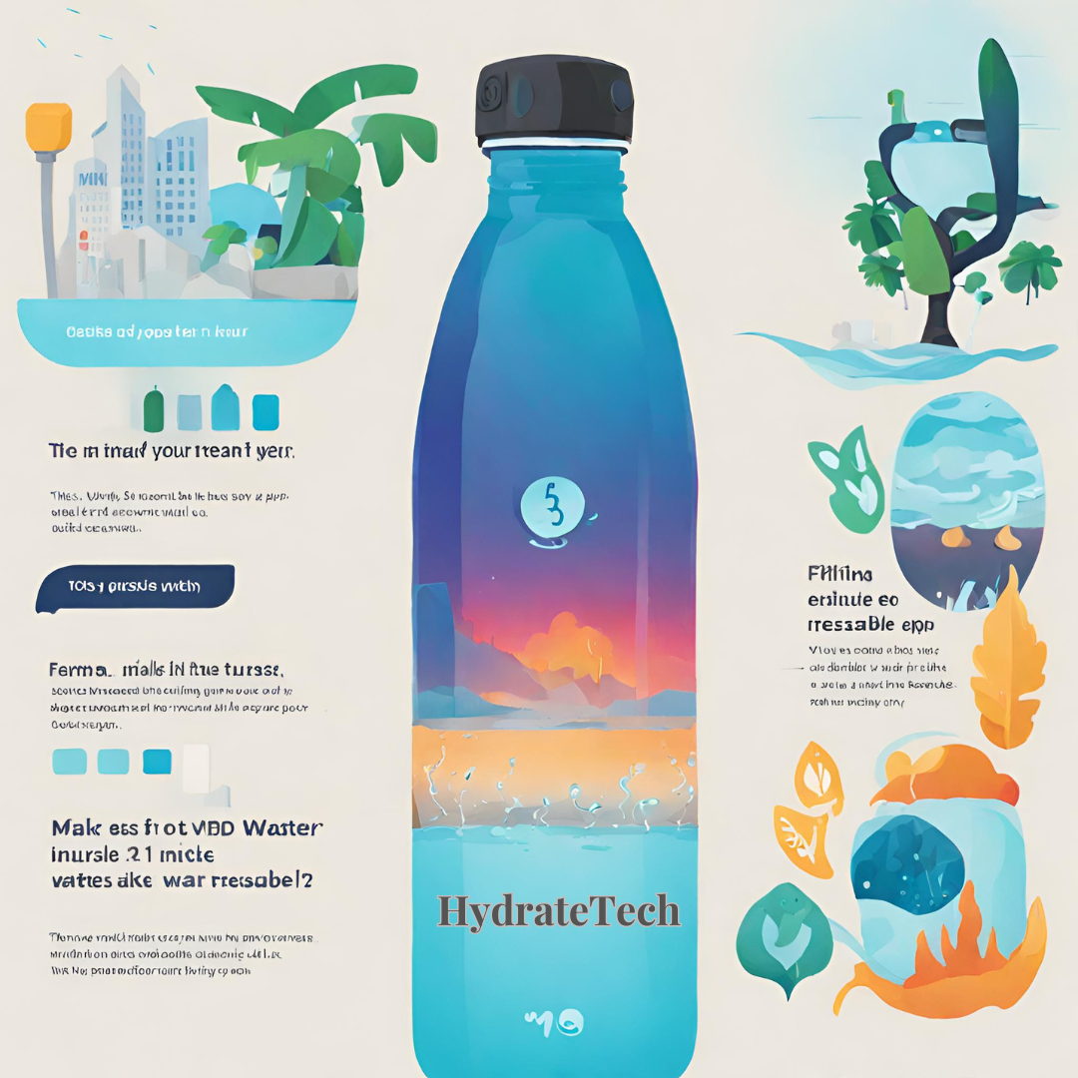

**Figure: Sketch of HydrateTech (Water Consumption Reminding App)**

**Explanation**

The sketch shows an easy-to-use mobile app designed to encourage water intake by alerting people to drink water at regular times, with alerts established on an hourly basis. The application's readily apparent user interface shows an illustration of a bottle of water, suggesting the present hydration level as well as encouraging customers to drink water to sustain a healthy body temperature all through the day. Customers can customize the amount of water they consume specifications and receive personalized updates guaranteeing they meet their water intake targets. By including this reminder function, the app hopes to foster good hydration practices and increase overall wellbeing amongst consumers in an effortless and readily available method.

# **Questionnaire**

We made a questionnaire to gather insights regarding customer feedback and their opinion on our product. We asked a number of questions from them like:

**How inclined are you to download and utilize the water consumption reminders app during the following year?**

1. Absolutely not Interested.
2. Most likely not Interested.
3. Neutral
4. Most Likely Interested
5. Absolutely Not Interested

**Which characteristics would you want to observe in a water intake reminders app to increase its attractiveness to consumers?**

______________________

**How much will you be ready to shell out for a water intake recall application that has customisable alerts and hydrated tracking capabilities?**

1. Less than 20 Dirhams
2. 20-40 Dirhams
3. 40-60 Dirhams
4. 60-80 Dirhams
5. Prefer Not to say

**After seeing the drawing for the water consumption reminders app, how inclined are you to purchase and utilize it over the following year?**

1. Absolutely Not
2. Probably Not
3. Neutral
4. Likely
5. Most Likely

**Can you think of additional functions or upgrades that could render a water intake reminders application more efficient and user-friendly?**

**__________________**

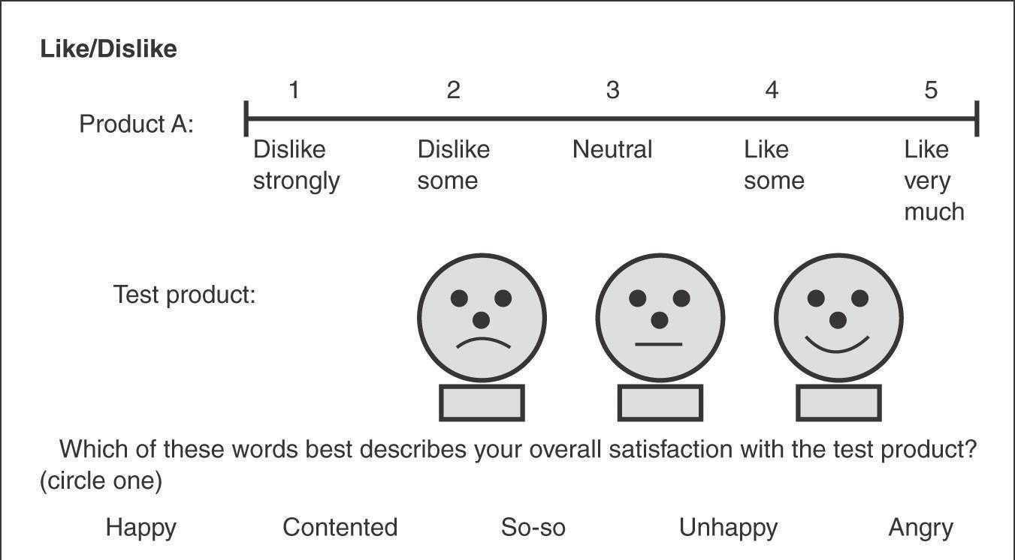

## **Responses**

Several major findings have been extracted from the input provided by thirty people who took part in the research we conducted on the water intake reminders app. To begin, when questioned what features they expected to see in an application like this that would make it more interesting, participants highlighted customisable notifications, hydration monitoring abilities, an appealing UI, and connectivity with additional wellness tracking applications.

Regarding cost, a majority of those surveyed expressed a willingness to spend between 40 and 60 Dirhams for a water consumption reminder app with customisable prompts and hydrating tracking tools, indicating they believe there is value in such products.In regards to how likely downloading and utilizing the application was, answers were varied, with a sizable proportion indicating neutrality or ambiguity. This shows that the app's advantages require greater clarity or illustration in order to improve consumer trust and engagement.

Concerns regarding utilizing a water consumption reminders app revolved on confidentiality, security of information, and possible dependability difficulties with reminder alerts. Finally, respondents suggested useful improvements and upgrades, such as connection with digital water bottles, awards for meeting hydration objectives, and personalized water regimens according to individual needs and behaviors.

**Is the product sustainable and environmentally oriented design?**

Yes, theinnovative product idea of a water bottle that can be reused with a reminder application is both environmentally conscious and ecologically friendly. To begin, using a reusable water bottle promotes people to use less single-use plastic, which reduces plastics waste as well as pollution significantly. By encouraging recycling rather than waste, the service contributes to a more environmentally friendly approach to hydration, in line with ecological preservation initiatives. Furthermore, the inclusion of a reminder app helps to improve the item's durability by encouraging effective water usage. By urging users to keep hydrated during the whole day, the smartphone programme helps eliminate the demand for single-use drinking vessels, for example plastic bottles of water or cup disposables, thus significantly reducing the adverse impact on the environment.In addition, the bottle's design uses environmentally friendly components like as reused plastic or metallic stainless steel, which contributes to the item's sustainability. The aforementioned substances are stronger while having a smaller environmental impact than traditional plastics, helping to conserve resources and minimize emissions of carbon dioxide. In general, the integration of reusable approach hydrated marketing, as well as environmentally friendly supplies provides the fresh idea for a product as an environmentally conscious and ecologically conscious option for customers.

Overall our product has gone through various phases:

Phase 1: Identification Phase

In this phase, industry research and customer feedback are used to discover possibilities and set the objectives and goals of the project for the water bottle that is reusable with a reminding application.

Phase 2: The Concept Development Process

Throughout that stage, inventive brainstorming meetings and conceptualization procedures are used to establish unique product ideas and attributes in response to recognised client demands and current market conditions.

Phase 3: Project Assessment Phase.

During this phase, the submitted ideas for products are examined using screen and scoring matrix to determine their practicality, survival, and compatibility with the project's objectives. Conceptual development and choice are based on outcomes of evaluation.

Phase 4: Construction Phase.

The selected item or design is meticulously designed, developed, and tested to assure performance, accessibility, and durability. Production processes are created, and collaborations with vendors and developers of applications are completed.

Phase 5: Launching.

The product is formally released in the marketplace, along with advertising campaigns to raise knowledge and increase sales. Initial consumer input is gathered and analyzed to guide subsequent product revisions and enhancements.

# **CONCLUSION**

Finally, "HydrateTech" is a game-changing approach that combines environmental consciousness and technical innovation. By providing a reusable water bottle with a reminder app, we not solely address the serious issue of single-use plastic trash, but also encourage healthy hydration practices. With its eco-friendly design and personalised advice, "HydrateTech" enables people to make sustainable decisions for themselves and the environment. This breakthrough solution has the potential to transform the way we hydrate, paving the path for a greener, healthier future for generations.

# **10. References**

* Dor, S. B. (2023). *Scoring Matrices*. YouTube: Home. Retrieved March 16, 2024, from https://bip.weizmann.ac.il/education/course/introbioinfo/03/lect5/scormatrix.pdf
* Mckenzie, Y. P., & Jamnadaas, E. (2020, June). *A content analysis of 'Water Apps' and prevention of urological diseases: Do apps really help?* Wikipedia. Retrieved March 16, 2024, from https://www.researchgate.net/publication/343291166_A_content_analysis_of_'Water_Apps'_and_prevention_of_urological_diseases_Do_apps_really_help
* Sharma, H. (2023, September 14). *(PDF) Effects of Smart Bottles on Water Consumption and Health Status of College Students*. ResearchGate. Retrieved March 16, 2024, from https://www.researchgate.net/publication/374241629_Effects_of_Smart_Bottles_on_Water_Consumption_and_Health_Status_of_College_Students
* Somani, B. K. (2020). *A content analysis of 'Water Apps' and prevention of urological diseases: Do apps really help?* NCBI. Retrieved March 16, 2024, from https://www.ncbi.nlm.nih.gov/pmc/articles/PMC7407778/
* Swastika, N. (2021, March). *WATER INTAKE APPLET BASED ON HUMAN EXCREMENT*. Wikipedia. Retrieved March 16, 2024, from https://www.researchgate.net/publication/349782022_WATER_INTAKE_APPLET_BASED_ON_HUMAN_EXCREMENT

# **11. APPENDIXES**

